TODAY’S DATE

To International Student Services at California Baptist University,

This letter is to verify that STUDENT’S FULL NAME is a(n) UNDERGRADUATE OR GRADUATE student enrolled in the PROGRAM NAME for the SEMESTER & YEAR semester at California Baptist University. As part of this program’s degree completion requirement all students must complete HOUR REQUIREMENT hours in an INTERNSHIP/PRACTICUM/CLINICAL to graduate from the program. STUDENT’S FIRST NAME is approved by our program to pursue completion of these hours at a university-approved site.
STUDENT’S NAME is completing NUMBER hours of observation at various locations, including NAME OF FACILITY from START DATE to END DATE. These observation hours are UNPAID OR PAID and are to fulfill part of a requirement for STUDENT’S FULL NAME program of study at California Baptist University.
If you have any questions, please contact me at the information listed below.

SIGNATURE

PRINTED NAME
PHONE NUMBER
EMAIL ADDRESS

September 1, 2022

To International Student Services at California Baptist University,
SAMPLE

This letter is to verify that Nathan Landry is a Graduate student enrolled in the Master of Engineering program for the Fall 2022 semester at California Baptist University. As part of this program’s degree completion requirement all students must complete 400 hours in an internship to graduate from the program. Nathan is approved by our program to pursue completion of these hours at a university-approved site.
Nathan is completing 200 hours of observation at Google Inc. from September 7, 2022 to December 14, 2022. These observation hours are unpaid and are to fulfill part of a requirement for Nathan’s program of study at California Baptist University.
If you have any questions, please contact me at the information listed below.
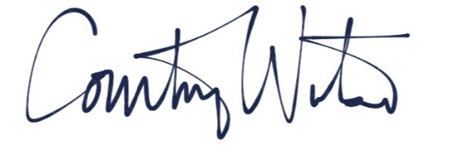

Courtney Watson
951-552-8474
cwatson@calbaptist.edu

