How to Enter Daily Time Worked + Transfer and/or Job Code:

From Workforce Now login page
> Myself > Time and Attendance > Time

When you are in eTIME, this is where you will enter all your time and attendance information.
- For the day you want to record your daily time, you will click in the box on the same row “Pay Code” and choose “Regular” from the drop down.
-Under the heading of “Amount” you will place your total time worked for that day.

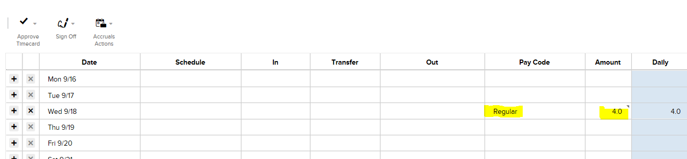

-If your department instructed use to use a cost center and/or job code for your shifts, in the “Transfer” column, click and choose “Search”.

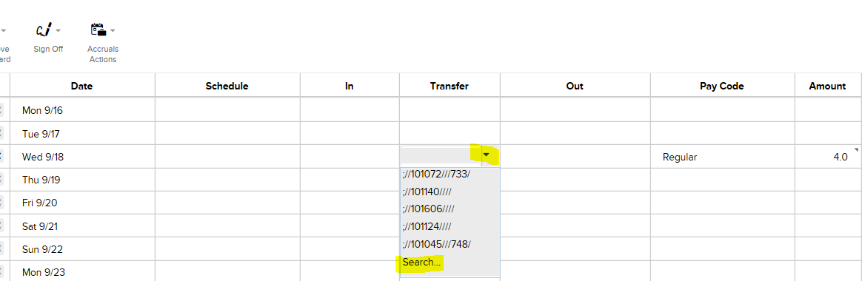

-A small window will appear. Click the “Labor Account” tab and click where is says “Department”. Click “Search” and type in cost center with no dashes (example: 101046). Click to choose cost center. Click where is says “Job Code”. Click “Search” and type the job code that you need. When finished, click “Apply” at bottom of window.
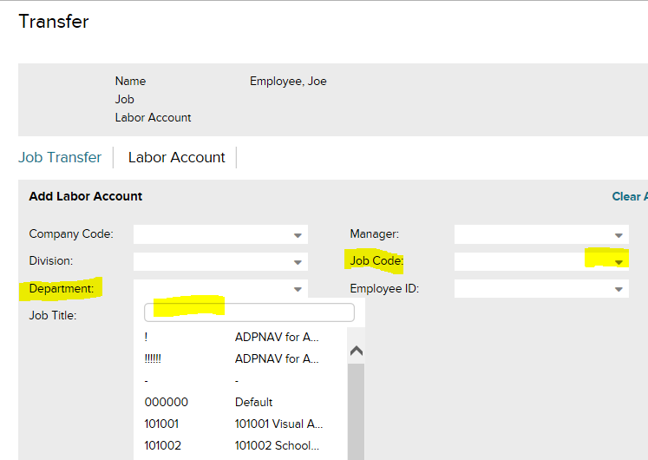

-Your timecard should now show the cost center and job code for that shift.

Make sure that you fill out the transfer section for each day that hours are logged in order to be paid at the correct amount.

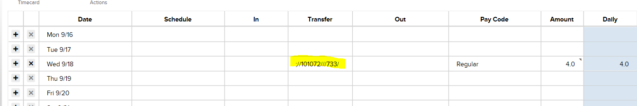

-After entering everything remember to click “Save” in the upper right to save the information.
-You will see in the light blue section that the time will transfer over and then the last column is a running total of time worked in the pay period.
-CBU’s pay periods are the 1st – 15th (paid on the 26th of the month), and 16th – Last day of the month (paid on the 10th of the following month).
-On the left upper side of the page you will see “Approve Timecard”. On the last day (or a day or two after) please review your timecard and make any changes necessary and then click “Approve Timecard”.

