Tracking Attendance through InsideCBU

Recording Attendance

- Click My Courses under Quick Links on the left side of the page, then click on the course from the dropdown menu.
- Click on the Attendance tab under the course name (See Below).
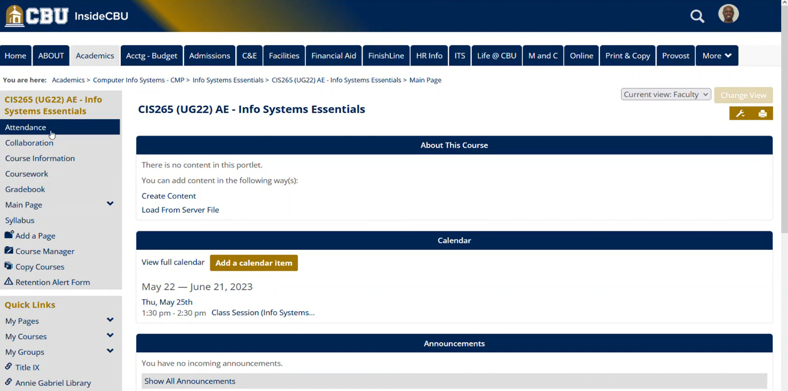
- The next page shows a list of all students enrolled in the course. By default, attendance will not be recorded immediately. Therefore, the message Attendance for this Session is not Complete will appear in red. The four options for attendance are: Present, Tardy, Absent, and Excused (See Below).
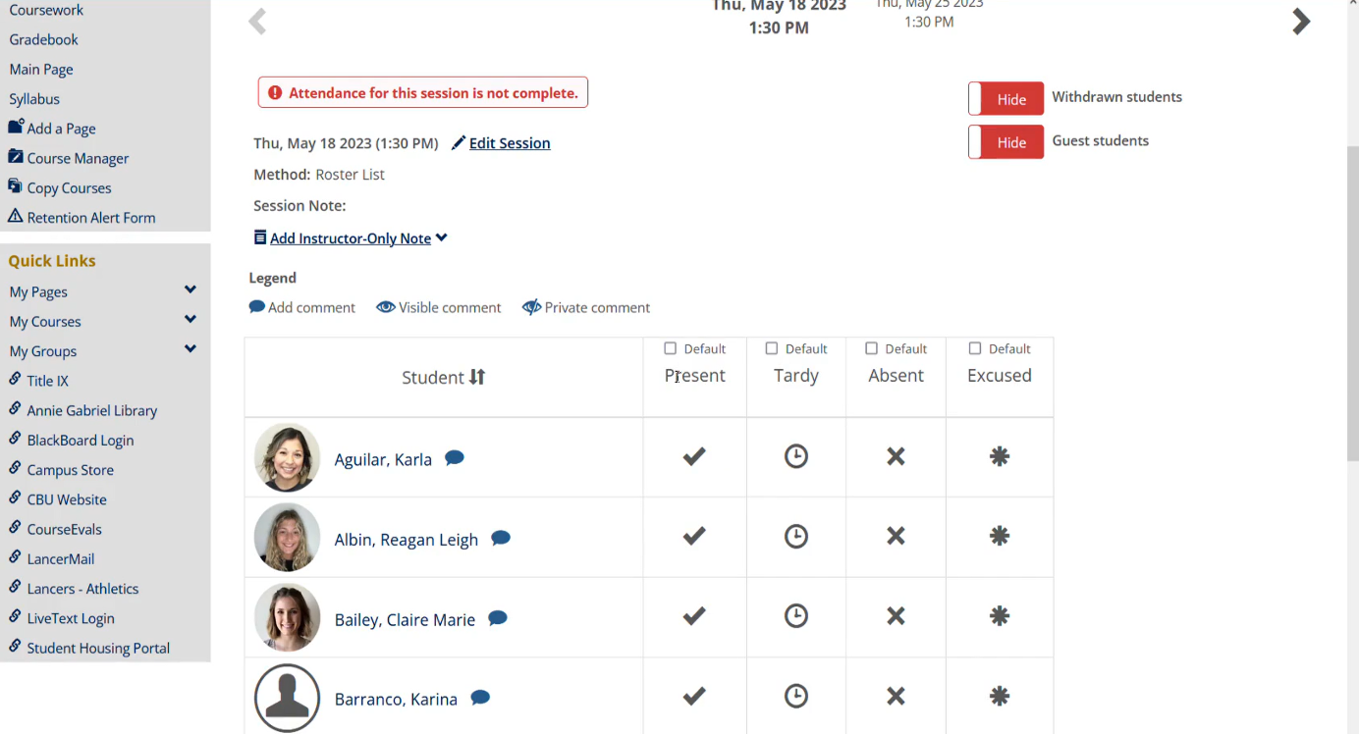
- Clicking default above each choice will set all students with that attendance selection. For example, if all students were present, clicking default above present will indicate in the system that all students were present that day. Having all students have their attendance recorded will change the message above to Attendance Successfully Completed (See below).
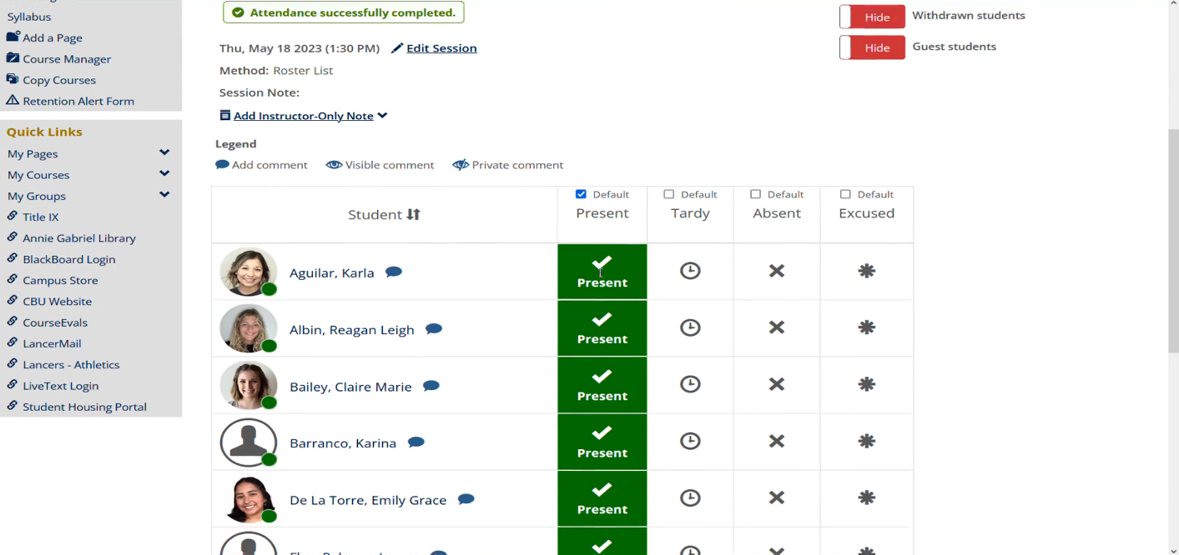
- Clicking on a new selection for a student after the default is selected will change their attendance record for that day. It is a best practice to use this feature to save time in recording student attendance (See Below).
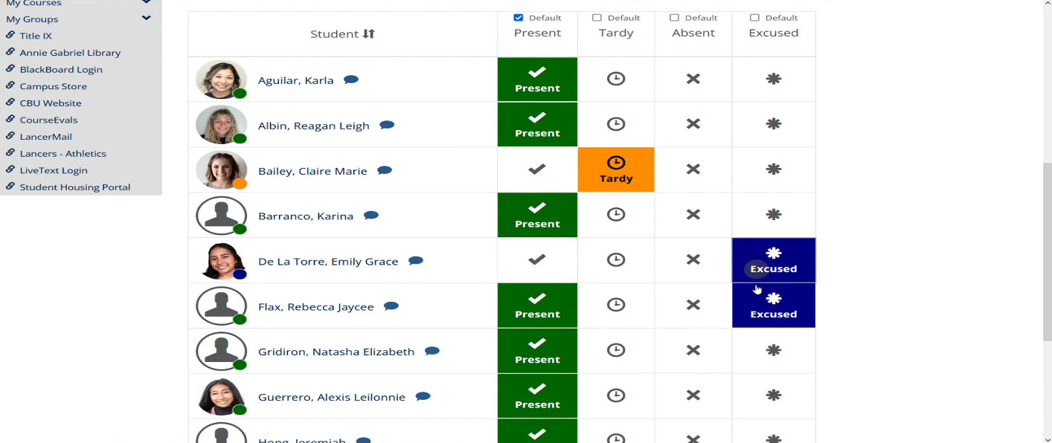
- You can also click the toggle buttons to show or hide withdrawn or guest students. You can also go to the Manage Session link (See video) or click the Add Instructor Only Note to write a memo regarding the session (See Below).
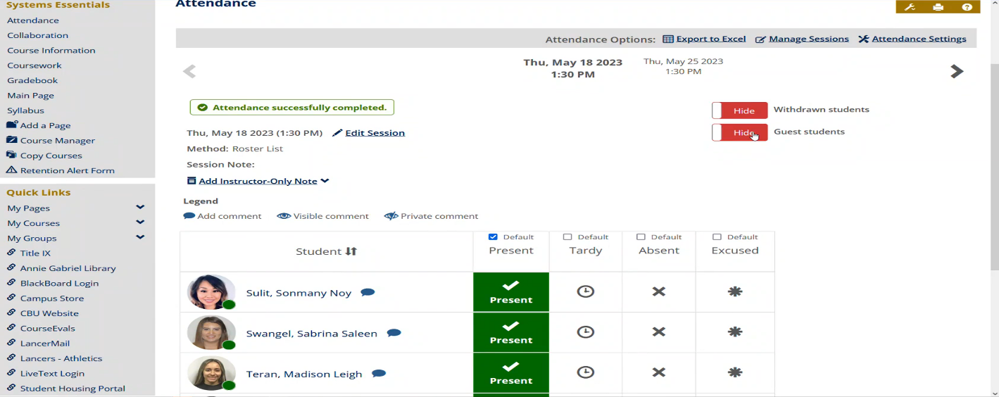
- You can also click the Blue Speech Bubble next to a student’s name to write a note about them specifically regarding their attendance for that particular session (See Below). You can also make that note visible to the student. Click save when completed. If a note is made visible to them, that speech bubble will turn into an eye instead to show the comment is visible to the student as well.
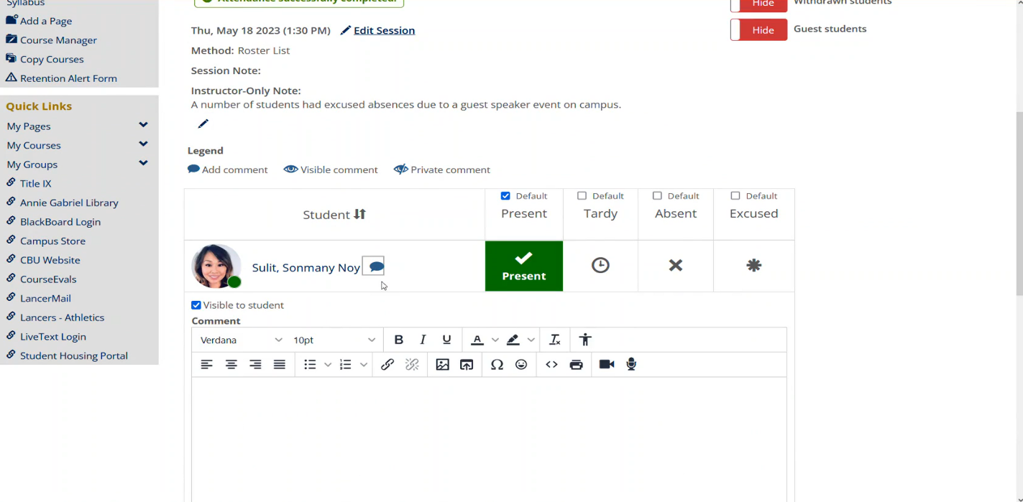

NOTE: See Attendance – Getting Started training document to learn how to navigate to the Attendance features in InsideCBU.

