Tracking Attendance through InsideCBU

Navigating to Attendance in InsideCBU

- Log into InsideCBU
- Click on the drop-down list under My Courses in the Quick Links tab. All courses you teach will be here. Then click on the desired course (See Below).
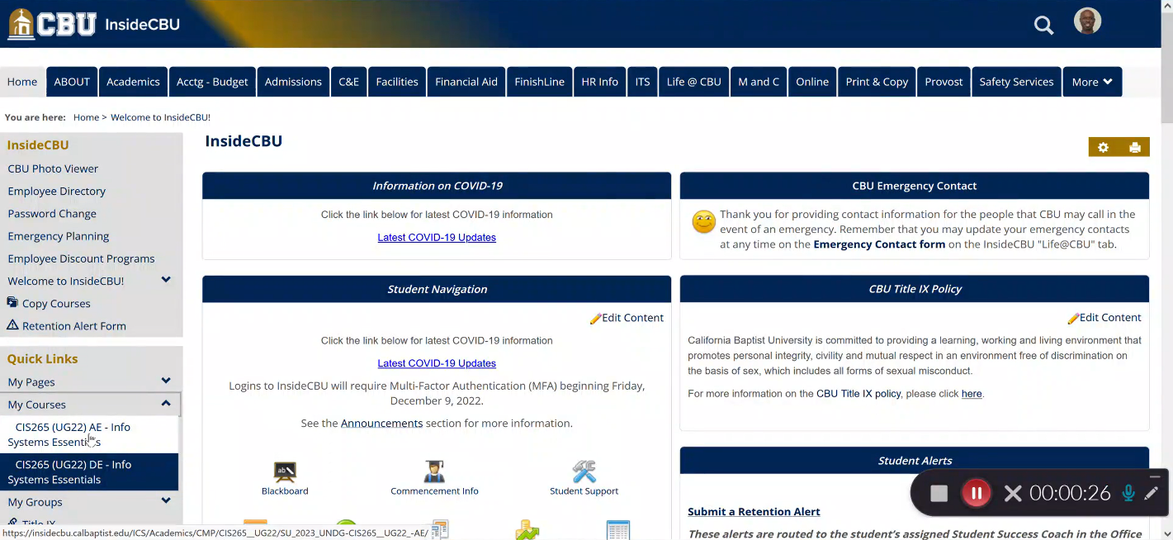
- Click on the Attendance button under the course name (See Below).
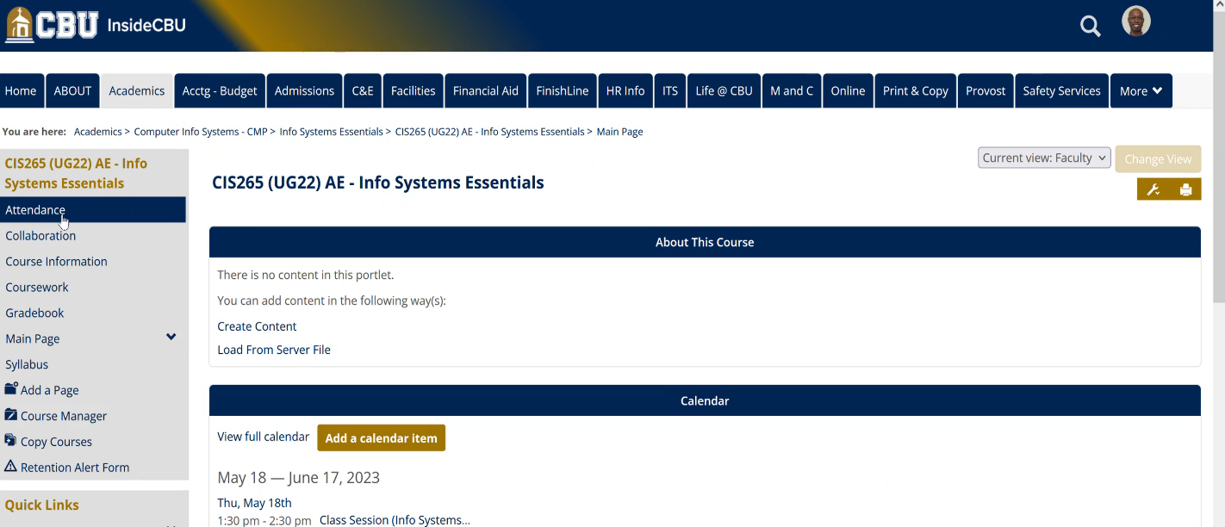
- This will bring you to the Attendance Page of the course. Here you can Add an Attendance Session, Edit a Session, Record Attendance, and Add Attendance (See Below).
