Access Zoom Participant Reports for Attendance
Step 1. Log into the Zoom web portal - https://zoom.us/
Step 2. Navigate to your account profile on the left left-hand side of the portal.
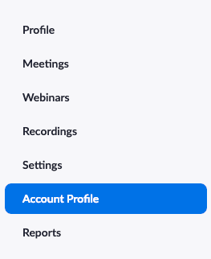
Step 3. Select “Usage Reports” and click on “Usage”
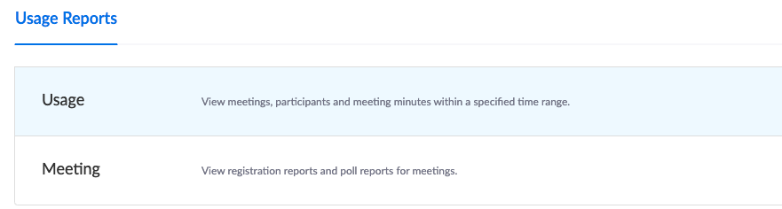
Step 4. Click on Participants and the list of students will appear if you want to export this data that is also an option on this page. The report will export as a CSV file that will open in excel.
