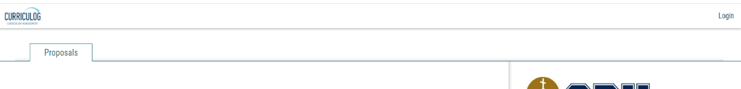
- Go to https://calbaptist.curriculog.com/ and login using your CBU credentials.

- Click on “New Proposal”
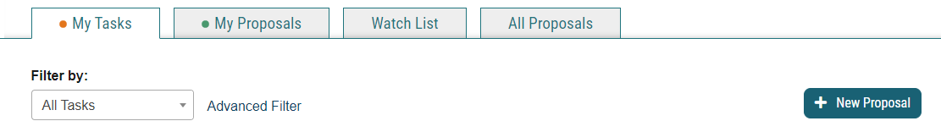

- Hover mouse over appropriate proposal and click on the green check to Start Proposal.

- Proposals with a blue page and arrow will allow you to import current data from the catalog (Course Deletion; Course Modification; Program Deletion; Program Modification)
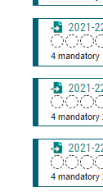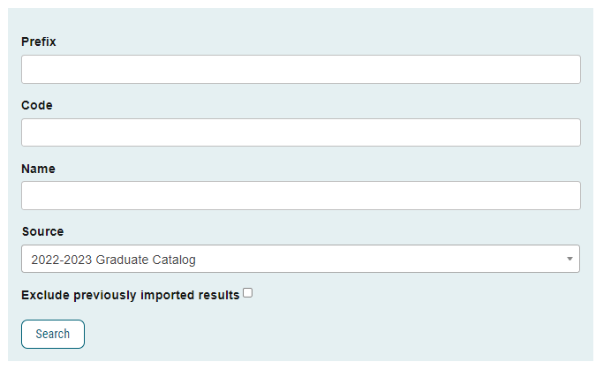
OR
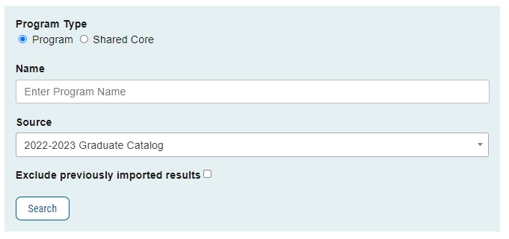

- Make your edits to the proposal. You can leave and come back – it will save all work.

- Click “Save All Changes”

- Attach supporting documents, click on the “Files” icon located in the Proposal Toolbox, then click on “Choose File”. Once you have selected the document, click the “Upload” button.
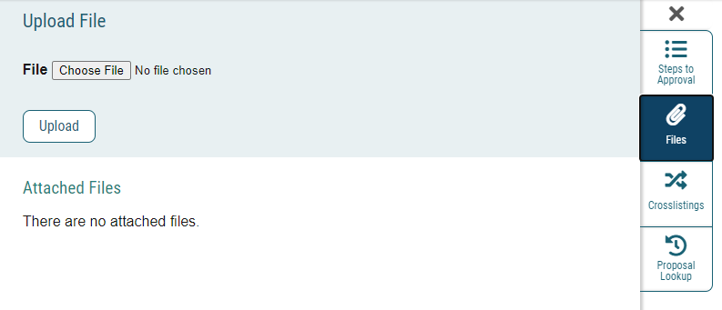
3
2
1

- At the top of the page, click the rocket icon to validate and launch the proposal.
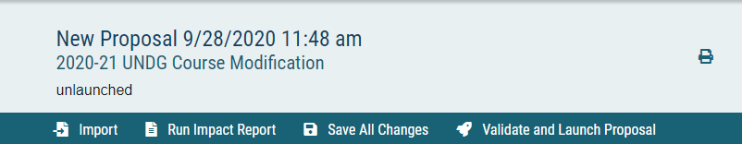

- If there are validation errors, click “Show Me” and add or save the data, then re-launch the proposal (Step 10).
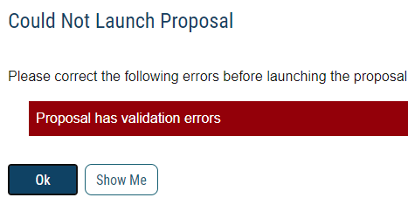

- Click the “Launch Proposal” button. You will be the first step in the approval process.

